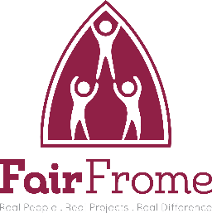
Fair Frome
Conflict of Interest Policy
Staff, volunteers, and Trustees of Fair Frome will strive to avoid any conflict of interest between the interests of the Organisation on the one hand, and personal, professional, and business interests on the other. This includes avoiding actual conflicts of interest as well as the perception of conflicts of interest.
The purpose of this policy is to protect the integrity of the organisation's decision-making process, to enable our stakeholders to have confidence in our integrity, and to protect the integrity and reputation of volunteers, staff and Trustees.
Upon appointment each Trustee, employee, and volunteer will make a full, written disclosure of interests, such as relationships, and posts held, that could potentially result in a conflict of interest. This written disclosure will be kept on file and will be updated as appropriate.
Guidance for Trustees and employees
Examples of conflicts of interest include:
1 A Trustee who is also a user who must decide whether fees from users should be increased.
2 A Trustee who is related to a member of staff and there is decision to be taken on staff pay and/or conditions.
3 A Trustee who is also on the committee of another organisation that is competing for the same funding.
4 A Trustee who has shares in a business or has family connections with a business that may be awarded a contract to do work or provide services for the organisation.
In the course of meetings or activities, Trustees and staff will disclose any interests in a transaction or decision where there may be a conflict between the organisation’s best interests and the individual’s best interests or a conflict between the best interests of two organisations that the individual is involved with.
After disclosure, a Trustee or employee may be asked to leave the room for the discussion and may not be able to take part in the decision depending on the judgement of the other Trustees present at the time.
Any such disclosure and the subsequent actions taken will be noted in the minutes.
This policy is meant to supplement good judgment, and staff, volunteers and Trustees should respect its spirit as well as its wording.

The Board of Fair Frome will carry out regular monitoring of policy and procedures. These Policies will be reviewed annually. The Policy and Procedures were accepted and adopted by the Trustees of Fair Frome
Name: | John Killah | Position: | Chair
Date: | 2.12.24 | Signature: | John Killah

