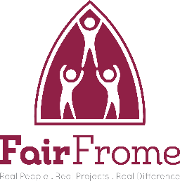
Campaigns and political activity policy
Trustees, Volunteers and Employees

As a charitable organisation Fair Frome relies on the funding and goodwill of the public. Fair Frome adheres to the conflict of interest guidelines as laid down by the Charity Commission, relating to the conduct of all its employees, trustees and volunteers.
Fair Frome supports the right of its trustees, volunteers and employees to be politically engaged and active.
However, active involvement in a political party or organisation (such as standing as a candidate for election) can on occasion give rise to questions of impartiality. If indeed there exists the risk of such conflict of interest, then it is for the individual to immediately advise the Chair of Trustees. Together with her/his Board of Trustees, the Chair will then review the situation and decide whether any such proposed involvement in a political party or organisation either gives rise to the possibility of impartiality or alternatively is incompatible with the charitable aims of Fair Frome. If indeed that is found to be the case, then the individual concerned may be asked to desist from any such political involvement or activity.
The Board of Fair Frome will carry out regular monitoring of policy and procedures. These Policies will be reviewed annually. The Policy and Procedures were accepted and adopted by the Trustees of Fair Frome:

Name: | John Killah | Position: | Chair of trustees
Date: | 2.12.24 | Signature: | John Killah

